If you’re going to San Francisco Call in the Angel on your way
The Angel Pub Kolossi
Charity Evening
In Aid of Cyprus Dogs Rehoming Association
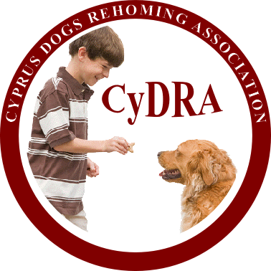
The Theme for the night is 60’s Flower Power
Let your hair down and dress for the occasion
Saturday 01 February 2014
Starting @ 2000 hrs/8.pm till late
Live Music to: Silver Fox and
The Angel Disco
Raffle/Auctions

Cost € 10.00 per person and includes a Buffet

